Assignment 5 – Proof-of-Concept Test Plan (/70 points)

**Due date:** See CANVAS for submission deadline and instructions

**Objectives:** A. Describe and justify your chosen design concept(s).

B. Propose an experimental plan to the teaching team, and receive feedback before beginning testing. Apply the project management techniques described in Chapter 12 of the course reader to your proof-of-concept testing.

**A. Design Concept Selection (/15 points)**

1. In Assignments 3 and 4 you proposed and evaluated several design concepts. Based on this evaluation, describe which concept you’ve decided is most feasible and are planning to pursue for proof-of-concept testing. Justify your decision based on your engineering analysis from Assignment 4, user needs, project objectives, and/or client/faculty advisor direction.

Alternatively, you may choose to do rapid prototyping of several design concepts instead of choosing one concept at this stage. If this is your plan, describe which concepts you plan to test, and why you decided to test several concepts. Justify your decision.

**B. Proof-of-Concept Test Plan (/55 points)**

1. Identify a critical function of your design that must be achieved in order for your design concept to meet your objectives. Explain why this function is critical to your design success. Describe the specifications (i.e. metrics with target numbers and units) that must be met in order for the critical function to be considered successful. (/7 points)
2. Pose one or more experimental questions related to your critical function that you plan to answer through proof-of-concept testing. (/5 points)
3. Develop an experimental plan to answer the above questions and test your design’s ability to successfully execute the critical function. Describe your proof-of-concept prototype and test plan. The experimental plan should involve measurements and data collection that will either support or disprove your design concept. Discuss good experimental design, repeatability, and required measurement precision to accurately assess the results of the concept test. Make sure it is clear how your test plan will enable you to answer the questions posed above and evaluate the critical function metrics. (/10 points).
4. Scope: Create a work breakdown structure (WBS) listing all required tasks for your proof-of-concept testing. Present your WBS in a table (indented list), or chart. Estimate the number of hours required for each task in the WBS. Provide justification that the proposed concept testing is appropriate level-of-effort for your group (~ 1 paragraph). Consider the number of students on your team and the weekly hours expected for a 3 unit class. Each student should be contributing a minimum of 9 hours/week for ~6 weeks, for a total of 54 hours minimum on proof-of-concept testing per person. For a team of 6 students, the proposed proof-of-concept testing should require approximately 324 hours. (/10 points).
5. Schedule: Using the above list of project tasks, create an Activity Network Diagram illustrating the sequential flow of prototyping tasks, including the estimated time required for each task, and highlighting the critical time path.

Also, create a project schedule presented as a Gantt chart that indicates the estimated timeframe for each task. (/8 points)

1. Spending: Provide a budget table for your proof-of-concept testing prototype. The budget table should include material and part information for major items. You should also indicate what your total project budget is (or an estimate, if your exact budget is unknown at this time). (/7 points)
2. Provide one paragraph summarizing your proof-of-concept testing tasks, schedule, and budget. Describe: level of confidence or uncertainties in budget and schedule, pivotal tasks, any opportunities for tasks to proceed in parallel, contingency plans in the event of unexpected results, justification for major budget items, etc. (/8 points)
3. The goal of the test plan is to determine feasibility of the project by performing a test on the most crucial function of the design. The most crucial function of the Quadruped Robot for Smart Agriculture is its ability to receive inertial data from an IMU, process it, and position its legs in response to this data. This fundamental ability can then be refined to produce walking, jumping, or balancing through the use of ROS2. This function can be tested without building the entire robot. A test stand will be designed which is capable of rigidly holding a single motor, encoder, IMU, microcontroller, servo driver board, and mock leg. This will allow basic testing of the control scheme and the functionality of the components. Measured metrics which define “functional” are laid out in Table 1. Our chosen design concept is to drive the motors using a servo control board, of which we will test two, an Orange Pi 5, and an affordable IMU. We chose this arrangement at the behest of our sponsors, because all our analysis of the Open Dynamic Robot Initiative motor configuration indicates it will be able to meet the requirements listed in Table 1, and finally to verify the robot’s ability to navigate rough terrain as needed for our users.

Table 1. A series of metrics to determine the feasibility of the quadruped control system.

| Metric | Value | Unit |
| --- | --- | --- |
| Positional Accuracy | < 0.5° | Degrees |
| Power Draw | < 200 W peak | Watts |
| Response Time | < 2 ms | Milliseconds |
| CPU Usage | < 12% | Percent |
| No Load Speed | > 2 rad/s at joint | Rad/s |
| Stall Torque | > 5 Nm at joint | Nm |

B)

1. The critical function of the Quadruped Robot is its ability to receive inertial data from an IMU, process it, and position its legs using this data. This is crucial to design success because it provides the foundation for the more complex functions of the robot such as walking, jumping, and balancing. With sufficiently sophisticated software this function allows the robot to achieve all types of locomotion required by the sponsor. The metrics that will evaluate the success of this design can be seen in Table 1. CPU usage, power draw, and response time are considered for one motor, and chosen such that there is enough overhead for seven additional motors. The remaining metrics are applicable to all joints, as they are all constructed identically.
2. Questions:
   1. Can the chosen motor drivers consistently read the encoder counts with the precision laid out in Table 1?
   2. What is the accuracy of the resulting leg position compared to the commanded position?
   3. What is the power draw of a single motor? If there are eight motors, what is the expected power draw of the final robot?
   4. What percentage of the Orange Pi’s CPU does closed-loop control of one motor using IMU data require? Is this much less than 1/8th of the Orange Pi’s capacity?
   5. What is the no load speed and stall torque of the motor with the ODRI modifications? Is this sufficient to achieve locomotion?
   6. What is the response time between change in IMU data and motor position reaction? Is this sufficient to react to the environment and maintain balance?
3. Experimental Test Plan
   1. **Step 1:**

Design of the test stand will be created in CAD. The design will have mounting points for a single motor, power distribution board, encoder, IMU, microcontroller, a servo driver board, and mock, single joint, leg. The test stand will be printed and assembled.

* 1. **Step 2:**

The Orange Pi and motor driver board must be configured. This includes flashing the Orange Pi with an OS and installing the necessary packages for the motor driver board (OdriveTool) as well as configuring the Orange Pi for CAN communication. The motor driver board must also be flashed with firmware and configured to execute position control on the brushless motor.

* 1. **Step 3:**

Wiring must be prepared and installed. This includes creating cables with appropriate JST connectors using crimp pins and housings. Various connections must be soldered. A power distribution board must be assembled for the low voltage components using buck converters. Motor phase wires must be created using barrel connectors. The CAN bus must also be created with appropriate resistors.

* 1. **Step 4:**

Code must be written which reads the I/O pins of the IMU, selects the motor driver address on the CAN bus and writes a desired position to the motor driver. Code which drives the motors for stall torque and no load speed tests will also be written. This code will need to have two different versions for each driver board.

* 1. **Step 5:**

Using the written code the positional accuracy, power draw, response time, CPU usage, no load speed, and stall torque will be measured with hand tools, high speed video, and software tools on the Orange Pi.

1. Work Breakdown

If the team works simultaneously on the physical test stand and the software components, four students can work on the test stand completing it in just over two weeks. This leaves two students to work on the software configuration completing it in about two weeks. If the team then splits into two groups, half can work on wiring and soldering while the other works on coding and troubleshooting. This should take just over two weeks. The last one to two weeks will consist of the entire team meeting together to complete the testing and measuring of the metrics. This can be done in two, three hour meetings with the whole team. The testing timeline will complete within six weeks according to this breakdown, which can be seen in more detail in Table 2.

Table 2. Estimated work breakdown and activity plan for this test.

| **Steps** | **Work Objectives** | **Estimated Work Time** | **Members Involved** |
| --- | --- | --- | --- |
| 1 | Building Prototype Body | 32 hours | Austin, Ben, Yang |
| 1a | Design Test Stand | 12 hours |  |
| 1b | Print and Assemble 3D-Printed Test Stand | 30 hours |  |
| 2 | Software Configuration (Pi and Driver Boards) | 58 hours | Kevin, Sam, Jordan |
| 2a | Remote Orange Pi Access | 6 hours |  |
| 2b | Individual Driver Board CAN communication configuration | 16 hours |  |
| 2c | Orange Pi Configuration | 6 hours |  |
| 2d | ROS2 + Python Integration | 30 hours |  |
| 3 | Preparation and Wiring all components (including soldering work) | 82 hours | Austin, Ben, Yang |
| 3a | Soldering to Connectors/Daisy chaining motor driver boards | 70 Hours |  |
| 3b | Seating control boards and wire cleanup | 12 Hours |  |
| 4 | Coding and Troubleshooting | 92 hours | Kevin, Sam, Jordan |
| 4a | Build 8-DoF Leg Control | 65 hours |  |
| 4b | IMU Feedback Control and Filtering | 18 hours |  |
| 4c | Build Movement Demos | 9 hours |  |
| 5 | Testing and Measuring Metrics | 36 hours | All |
| 5a | Positional Accuracy Test | 9 hours |  |
| 5b | Power Draw Tests | 9 hours |  |
| 5c | Joint/Body Strength Test | 18 hours |  |

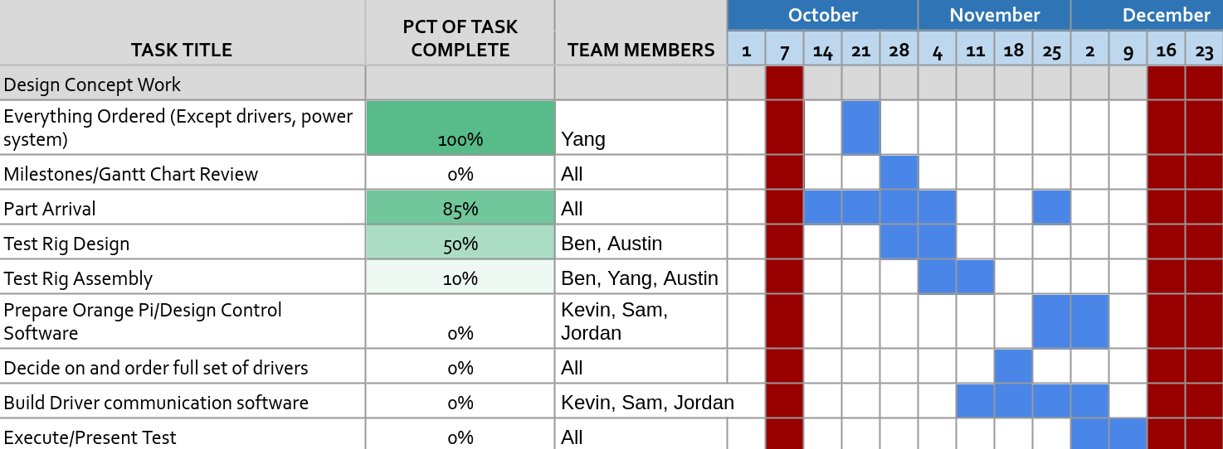

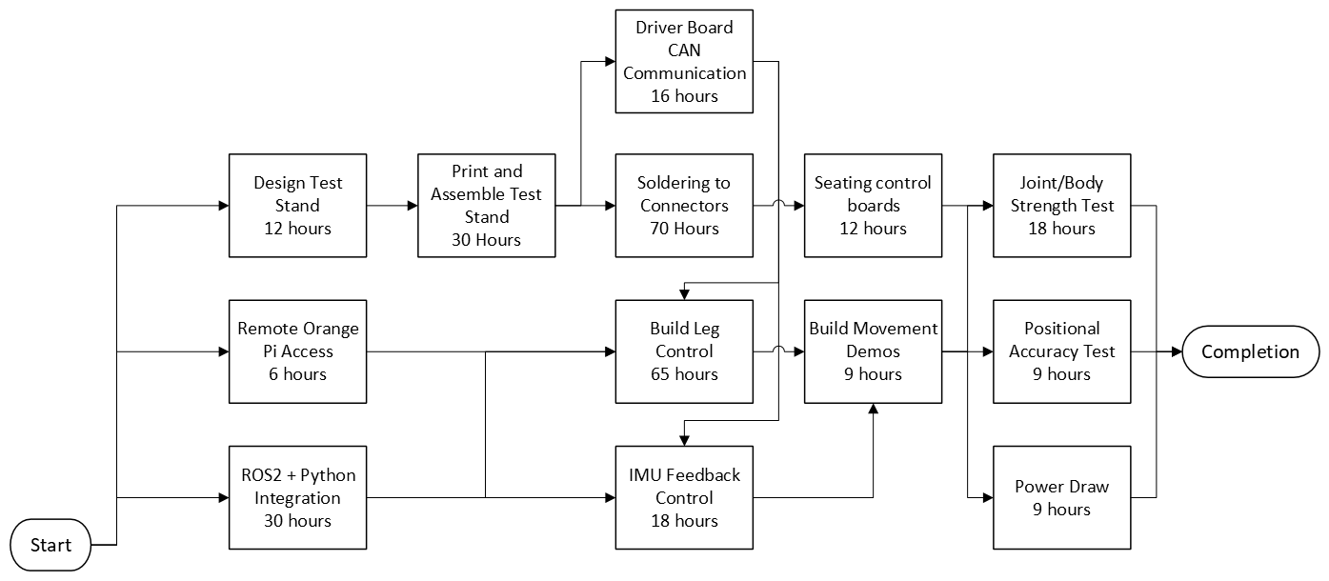

1. Bill of Materials.

Test Plan Pricing:

| **Part** | **Supplier** | **Quantity** | **Price Individual Part** | **Price All Parts** | **Total Spent** |
| --- | --- | --- | --- | --- | --- |
| Brushless Motor (2pk) | Lab | 1 | $0.00 | $0.00 |  |
| Bearing Output Shaft | 123-Bearing | 4 | $5.02 | $20.08 |  |
| Bearing Motor Shaft and Center Shaft | 123-Bearing | 3 | $8.03 | $24.09 |  |
| Orange Pi | Amazon | 1 | $127.99 | $127.99 |  |
| CF-PLA | Bambu Labs | 1 | 34.99 | $34.99 |  |
| Servo Driver (cheap) | Amazon | 1 | $33.99 | $33.99 |  |
| ODrive S1 | ODrive Robotics | 1 | $149 | $149.00 |  |
| J11 Connector | Digikey | 12 | $0.65 | $7.80 |  |
| J11 Crimp Pins | Digikey | 450 | $0.03 | $14.40 |  |
| J16, J17, J1 Pre-crimped connectors | Amazon | 1 | $18.99 | $18.99 |  |
| SanDisk 32GB microSD | Amazon | 1 | $7.85 | $7.85 |  |
| Braking Resistors (5ct) | Amazon | 2 | $9.99 | $19.98 |  |
| IMU 6-Axis Board | Adafruit | 1 | $11.95 | $11.95 |  |
| Encoder for Testing | Digikey | 1 | $65.90 | $65.90 | $537.01 |

Full Robot Estimate (includes test plan components, reused and otherwise):

| **Part** | **Supplier** | **Quantity** | **Price Individual Part** | **Price All Parts** | **Cost Breakdowns** | **Total Spent** |
| --- | --- | --- | --- | --- | --- | --- |
| M3 x 5 SS (50 pcs) | mcmaster | 1 | $5.09 | $5.09 | **Subtotal** | $2,740.67 |
| M3 Screw and Nut Assortment | Amazon | 1 | $7.99 | $7.99 | $2,343.26 |  |
| M3 x 4.5 Helicoil (10 pcs) | mcmaster | 3 | $8.98 | $26.94 | **plus ODrive** |  |
| M3 x 6 Helicoil (10 pcs) | mcmaster | 3 | $11.35 | $34.05 | $3,569.25 |  |
| Brushless Motor (2pk) | Lab | 4 | $0.00 | $0.00 | **or plus Cheap Amazon Driver** |  |
| Bearing Output Shaft | 123-Bearing | 16 | $5.02 | $92.42 | $2,764.18 |  |
| Bearing Motor Shaft and Center Shaft | 123-Bearing | 24 | $8.03 | $166.56 |  |  |
| Bearing Timing Belt Tensioner | 123-Bearing | 16 | $6.24 | $112.64 |  |  |
| Timing belt first stage | Belting Online | 8 | $5.96 | $47.71 |  |  |
| Timing belt second stage | Belting Online | 8 | $8.94 | $71.53 |  |  |
| Encoder Kits | PWB | 8 |  | 1,245.77 |  |  |
| M3 x 16mm Plastic Screws (20 pcs) | Amazon | 1 | $8.89 | $8.89 |  |  |
| 20 AWG Cu Wire (6 color, 50 ft each) | Amazon | 1 | $27.99 | $27.99 |  |  |
| 26 AWG Cu Wire (6 color, 50 ft each) | Amazon | 1 | $24.49 | $24.49 |  |  |
| 18 AWG Cu Wire (2 color, 25 ft) | Amazon | 1 | $9.50 | $9.50 |  |  |
| Banana Plugs Connector 2mm (30 pcs) | Amazon | 1 | $10.49 | $10.49 |  |  |
| Wire Splicer (2, 3, 5 Way) Kit | Amazon | 1 | $14.98 | $14.98 |  |  |
| Amass XT30 Connector Male Female | Amazon | 1 | $8.58 | $8.59 |  |  |
| Ribbon wire 1.27mm pitch | Amazon | 1 | $13.99 | $13.99 |  |  |
| 4mm Banana Plug (female adapter) | Amazon | 1 | $9.90 | $9.90 |  |  |
| 4mm Banana Plug (male adapter) | Amazon | 1 | 9.99 | 9.99 |  |  |
| Pin Header 2,54 mm pitch |  | 1 | 1 | $1.00 |  |  |
| 12-Bit Ring LEDs (maybe not) | Amazon | 1 | $8.99 | $8.99 |  |  |
| Right Angle Pin Header |  |  | $0 |  |  |  |
| Orange Pi | Amazon | 1 | $127.99 | $127.99 |  |  |
| CF-PLA | Bambu Labs | 2 | 34.99 | 69.98 |  |  |
| Servo Driver (cheap) | Amazon | 8 | $33.99 | $271.92 |  |  |
| ODrive S1 | ODrive Robotics | 8 | $149 | $1,192 |  |  |
| J11 Connector | Digikey | 12 | $0.65 | $7.80 |  |  |
| J11 Crimp Pins | Digikey | 450 | $0.032 | $14.328 |  |  |
| J16, J17, J1 Pre-crimped connectors | Amazon | 1 | $18.99 | $18.99 |  |  |
| SanDisk 32GB microSD | Amazon | 1 | $7.85 | $7.85 |  |  |
| Braking Resistors (5ct) | Amazon | 2 | $9.99 | $19.98 |  |  |
| IMU 6-Axis Board | Adafruit | 1 | $11.95 | $11.95 |  |  |
| Encoder for Testing | Digikey | 1 | $65.90 | $65.90 |  |  |
| Heat Set Insert tip Tool | Amazon | 1 | $38.99 | $38.99 |  |  |

1. Summary

Our proof of concept test plan requires us to assemble a test rig with a single joint “leg” controlled by a single servo control board linked to an Orange Pi and IMU. With this testing we will determine the feasibility of both powering eight servo control boards with the Orange Pi while processing IMU data, as well as our ability to design a control system for this arrangement. Our schedule prioritizes foundational work such as design of the physical test rig or installing ROS2 on the Orange Pi in the next couple of weeks while the weeks after focus on actual building of the test rig and writing of code for the test. We are, at present, far below budget and even our more extreme estimate is less than half of our maximum, so we have little concern on that front. As most of our costs arise from the motors, encoders, and drivers, our test plan will verify all of these components for one eighth of the system before we commit to the full robot. For the code preparation timeline, we are somewhat more uncertain, as even the most experienced members of our team have only basic ROS2 knowledge. This leads to the concern that the learning curve for our use case may be steeper than anticipated and consume vastly more time than we hope. To mitigate this, we have ideas for alternate test systems that rely on direct one input yields one output arrangements as opposed to the full closed loop control we are currently working towards. Beyond that, however, we are confident in our test plan.